**RECURSIVE FEATURE ELIMINATION**

A machine learning dataset for classification or regression is comprised of rows and columns, like an excel spreadsheet. Rows are often referred to as samples and columns are referred to as features, e.g. features of an observation in a problem domain.

Recursive feature elimination (RFE) is a feature selection method that fits a model and removes the weakest feature (or features) until the specified number of features is reached.

CLASSIFICATION

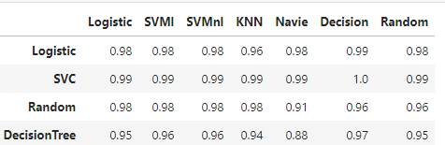

RFE Classification taking n=3 feature I think the best model of feature selection.

l.e, Logistic compare to logistic, svm1,svmn1,knn,navie ,decision ,random ,the best model of Logistic and decision. And SVC compare to logistic, svm1,svmn1 ,knn, navie ,decision ,random, the best model of SVC and decision. and Random compare to logistic, svm1,svmn1,knn,navie ,decision ,random I think best model of Random and all things being equal. And Decision Tree compare to logistic, svm1,svmn1,knn,navie ,decision ,random, the best model of Decision Tree and decision tree. And over all performance best model SVC and Decision Tree.

REGRESSION

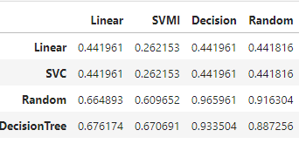

RFE Regression taking n=3 feature, I think the best model of feature selection.

I.e, Linear compare to linear, svml, decision, random, i think not satisfaction of all models. And SVC compare to linear, svml, decision, random same to not satisfaction. And Random compare to linear, svml, decision, random, the best models of Random and Decision. And Decision Tree compare to linear, svml, decision, random, the best model of Decision Tree and Decision, over all performance of best model Random Forest and Decision Tree.